**250317 Draft Press Release - Clitheroe Town Wells Campaign Update**

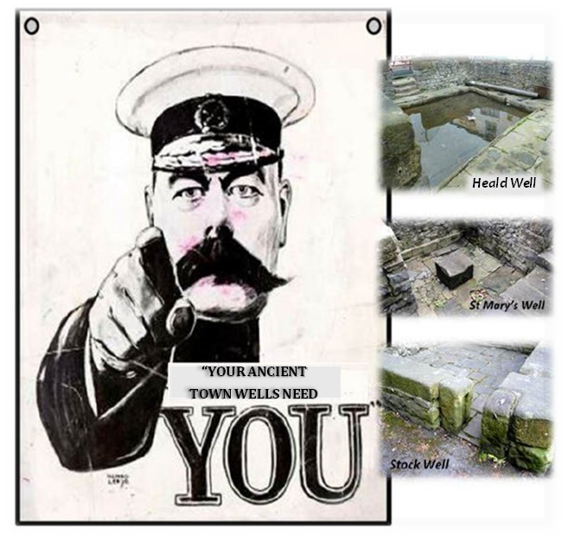Clitheroe Town Wells Conservation Campaign continues to develop the case for Ribble Valley Borough Council (RVBC) to accept its de-facto responsibility for ownership of all three of Clitheroe’s ancient former Public Town Wells. To date, as result this Campaign bringing this responsibility to their attention, they successfully Registered Stock Well.

Without Registered Titles no significant - increasingly necessary repair and maintenance works - can be done to these Listed Grade II structures. Thus all three - including Stock Well - continue to deteriorate.

Before further attempts to have RVBC accept this responsibility, CTWCC continues to promote the significance of all three of these pre-Norman sites. Collectively, they represent a unique Heritage Asset to the Parish of Clitheroe and Ribble Valley District and could be a major Tourist attraction as demonstrated by the many Well Dressing Festival in the Peak District and elsewhere.

The latest developments in the Campaign include:

* A grant from the Bowland Charitable Foundation to promote the aims of the Campaign within the Ribble Valley Community
* Guided Tours of the Wells for Local Schools - the first of these taking place w/c 28th April
* Post Grad UCLan Building Conservation Students provision of detailed Surveys and Significance reassessments in accord with Historic England Guidelines.
* An on-line Change.Org petition (*see website*) to support the forthcoming motion for further applications to be made to the Land Registry by RVBC, and
* The continuing development of Campaign’s website [***www.clitheroe3wells.com***](http://www.clitheroe3wells.com)

Clitheroe Town Council, Clitheroe Civic Society and Clitheroe’s Town Team and have all recently reaffirmed their support for CTWCC’s case that our Council can - and should - accept its communal, historic and legal obligations to Registered Title for all three sites. Independent Legal and Professional advice to CTWCC - from five separate sources - confirms the collective view that the only issue preventing RVBC from applying for Registration of the two remaining unadopted sites – ***“is the will to do so’***. CTWCC now hopes that Councillors and Officers will collectively support this proposal when presented to them. This would be to their Municipal credit and create legacy to the new incoming administration of the significance of Clitheroe’s Historic, Social, and Heritage Assets to this community.

Once title for all sites is obtained, CTWCC has set out a suggested ‘Roadmap’ for their future based on the considerable collective Conservation Project experience of its Steering Committee and Supporters. In the current absence of RVBC’s desire to take future management responsibilities, this envisages all three sites being transferred to some other Registered Charitable ‘not for profit’ organisation. This with the confirmed aim to effectively interpret, maintain, and promote these sites to the lasting benefit of the community. **There would thus be no significant impact on the Council’s Finances -** and the reverse would actually be the case. This would see the care of these unique sites kept local, in advance of RVBC’s being rolled up into an - as yet unknown, but inevitably larger - Unitary Authority.

All wishing to support the aims of the Campaign are requested to sign the ‘Save the Wells’ Petition via our website link and also make your views known to your Councillor.

Steve Burke Dip.Arch. (Oxf’d),

Secretary,

CTWCC

[www.clitheroe3wells.com](http://www.clitheroe3wells.com)

(*534 words*)