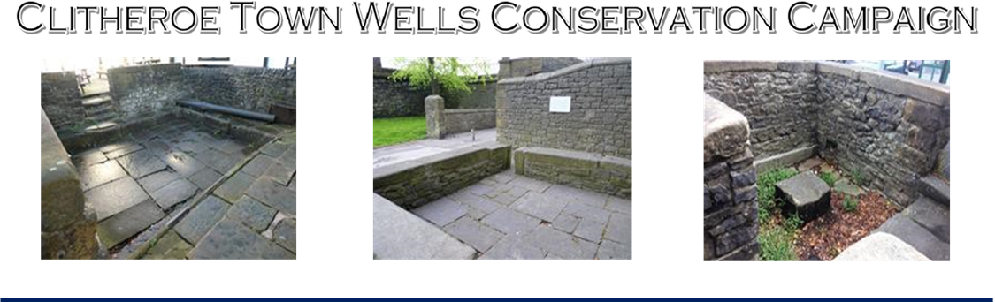

***HEALD WELL STOCK WELL ST.MARY’S WELL***

*‘To secure a meaningful and lasting future for all three of Clitheroe’s Ancient former Public Town Wells’*

**DRAFT Minutes of CTWCC Meeting: 11.00 am, 11th Dec. 2024**

Venue: Clitheroe Town Council (CTC) Chambers, Church Street, Clitheroe

**1.0 Present**

**1.1 For CTWCC Steering Committee:** Steve Burke (SB) CTWCC Steering Committee Secretary; Shirley Penman (SP) CTWCC Steering Committee; Len Middleton (LM)Steering Committee; Steve Ragnall (SR) Steering Committee; Cllr. Ian Brown (IB) CTC for Salthill Ward; Cllr Bill Holden (BH) RVBC St. Mary’s Ward; Mark Alexander Jackson (MAS) Building Conservation Surveyor and Final Year UCLan Masters Student.

**1.2 As Public Observers:** Cllr Tony Austin (TA) ***Observe****r* RVBC Billington & Langho; David Berryman (DB) ***Observe****r* & Former RVBC Cllr and Geological Advisor to CTWCC.

**2.0 Apologies from Invited Observers:** Cllr Corney, R Stephenson, C Sutton, P Llywelyn, T Taylor

**3.0 Proposed Adoption of Constitution** (Steering Committee Members only)

**3.1 Motion to adopt:** Proposed by SP, Seconded by SR. **Unanimously approved**

**3.2 Appointment of Officers:**

**3.2.1** SR for Chairman, proposed by SB and seconded by LM. **Unanimously approved.**

**3.2.2** SB for Secretary, Proposed by SP and Seconded by SR. **Unanimously approved.**

**3.3 Constitution signed and witnessed:** Signed copy attached (for CTWCC Members). Immediate actions arising from adoption of the Constitution was a Review of Current Activities as recorded below.

**4.0 Continued engagement with Local Councillors and Officers**

**4.1 Review of CTC Progress**

**4.1.1** The most recent approach for a further meeting with the Community Services Director, Alan Allen (AA), and CS Chair, Cllr Stuart Hirst (SH) was led by Cllr Ryan Corney (RC). At the request of AA and SH, a detailed dossier of new and, significant existing, information supporting the case for RVBC’s applications to the Land Registry for Heald and St. Mary’s Wells was prepared and submitted for their consideration by RC on behalf of CTWCC on 12th Sept. 2024.

**4.1.2** By this meeting no response had been received by CTWCC from RVBC via RC. IB’s understanding was that RVBC, while hinting that they were now finally ‘*considering*’ the ‘ownership issues’, *they had requested further information from CTWCC’.*

**4.1.3** Subsequent to this meeting AA’s response to RC dated 17th Dec was obtained. It stated:

*‘Hi Ryan, Thanks for the email, we are looking at ownership but currently the position remains that we don’t think we can take them on. I do feel this shouldn’t stop any group developing activity at the wells though.  The surveys should be very useful and interesting, I think. Thanks Adam’.*

**4.1.4** It was unanimously agreed that the absence of any formal or direct response to the information provided by CTWCC to RVBC was disappointing, contradictory and confusing.

**4.1.5** It was unanimously agreed that CTWC would now review its existing strategy of trying to meet with Officers and Senior Councillors. A Meeting to do so was subsequently agreed for 11.00am on 17th Jan 2025.

**4.1.6** It was further agreed by all attending this meeting that the case for adopting all three wells should be considered at either at Full Council and/or Community Services Committee meeting at a date to be agreed. Just when this should be, to be considered further.

**4.2 Review of Progress with RVBC:** None to date as recorded above

**5.0 Advice and support from Stakeholders/Supporters**

**5.1** UCLan: Dept of Post Grad Conservation Studies: Student & Post Grad Surveyors involvement

* Measured Survey and Condition Report: An update of work in progress to be requested in time for the

next meeting on 17th Jan. 2025

* Heritage Assessment and Statement of Significance: An update of work in progress to be requested in

time for the next meeting on 17th Jan. 2025.

**5.2** Manchester University: Centre for Medieval and Early Modern Studies: Review of Legal Issues:

* SB reported that, for the time being no further advice or assistance is being sought from MU. For the record -and at the core of this present unwarranted impasse - Dr Ashey Hanney’s (Lecturer in Property Law) states in his email of 3rd Oct. 2024:

‘……. *I'm very grateful for your including all of the previous advice and evidence, both historical and legal that you've obtained. In fact, you've answered what my first question was going to be, that being whether there was any evidence of ownership/responsibility for the wells. I had thought to look at the records of the Honour of Clitheroe, to see if there was reference to the wells in any of the original grants,* ***but the Leet Court (and more recent) records appear to do the trick of demonstrating the local authority taking responsibility.******Certainly, to a standard that I believe the land registry would be happy with (as demonstrated by them registering one of the three wells already).***

**6.0 AOB**

**6.1 Campaign Promotion and Publicity**

**6.1.1** **Public Meeting and Presentation:** SR & SB are working on a short Audio-Visual Presentation to open up a. The venue for this has now been confirmed as The Moot Hall, Church Street at 11.00am on Saturday 25th January. This will be ‘trailed’ in Local Press, Social Media and by Posters prepared and distributed across the town.

**6.1.2** **Castle View Free Newssheet:** CV is to run a Press Release in the last edition of 2024 (and did).

**6.1.3** **Website**: BH is developing this and is now accessible via <https://www.clitheroe3wells.com/> it is currently password protected. This is **CTWCCin** SB and BH to meet on20th Dec to continue development, (and did).

**6.1. 4** It was suggested that SB ‘appear’ on Cllr Graveston’s Ribble FM programme.SB agreed to contact MG.

**6.2 Future Meetings:** General Committee Meetings: Dates for GCM’s to be agreed at the next Committee Meeting to be held at **11.00am in the New Inn (Back Room) on Friday 17th 2025.**

**FIN**

**Clitheroe Town Wells Conservation Campaign**

**Secretary: Steve Burke Dip.Arch (Oxf’d)**

**Tel: 01200 425528 M: 07975 518113 Email:** [**sbcaltd@outlook.com**](mailto:sbcaltd@outlook.com)

**Website** [**www.clitheroe3wells.com**](https://gbr01.safelinks.protection.outlook.com/?url=http%3A%2F%2Fwww.clitheroe3wells.com%2F&data=05%7C02%7C%7C13924f06cfab4227e64a08dd187132d7%7C84df9e7fe9f640afb435aaaaaaaaaaaa%7C1%7C0%7C638693596667382876%7CUnknown%7CTWFpbGZsb3d8eyJFbXB0eU1hcGkiOnRydWUsIlYiOiIwLjAuMDAwMCIsIlAiOiJXaW4zMiIsIkFOIjoiTWFpbCIsIldUIjoyfQ%3D%3D%7C0%7C%7C%7C&sdata=lKfpk4Fdd0RxDgisnD8uXByzEkgYxtVFxOz1sxfxfYU%3D&reserved=0)